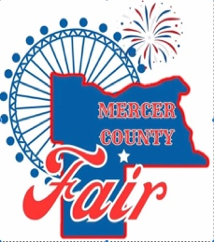
Mercer County Fair
Commercial Vendor Application

Thursday June 26th – Saturday June 28th, 2025

This application/contract is neither an offer nor a guarantee of booth space. If you have questions regarding the application, please call Mark Hafner at 701-891-9753 or email Mark at mdhafner@westriv.com.
.

Vendor Name:

Electricity:

Tax ID:

Contact Name:
MAILING ADDRESS:
EMAIL:
PHONE:

ALL 3 DAYS FOR $125.00
GATE PASS INCLUDED

Thursday June 26th^{th} 4-9 pm
Friday-Saturday June 26th- 27th Noon to 9:00 pm

Number of Booths:  10’x10’ |  | Signature:

Your booth should fit within the 10’x10’ space assigned, or spaces paid for. If not, you will be asked to purchase an extra space/booth. Your signature is an agreement that you, as the vendor, will be set up at the Mercer County fairgrounds from June 26th- 28th, 2025 unless extraordinary circumstances warrant early departures, and no shows will forfeit their deposit. Vendor fees are non-refundable.

Signed contracts are due June 1st, 2025. After this date, the fair cannot guarantee booth space.

Make Checks Payable: Mercer County Fair PO Box 640 Beulah, ND 58523

No Driving on the fairgrounds after 4:00 pm on Thursday, June 26th , 2025. Vendors will need to enter the fairgrounds through the gates. All vehicles must be off the fairgrounds prior to the fairgrounds opening.

