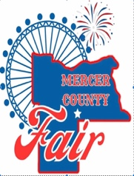
Mercer County Fair
Food Vendor Application
Wednesday June 25th – Saturday June 28th, 2025

This application/contract is neither an offer nor a guarantee of a space. If you have questions regarding the application, please call Mark Hafner at 701-891-9753 or email Mark at mdhafner@westriv.com.

Vendor Name:

Electricity:

Tax ID:

Contact Name:
MAILING ADDRESS:
EMAIL:
PHONE:

ALL 4 DAYS FOR $500.00
GATE PASS INCLUDED
Wednesday June 25th Inspection at Noon
Thursday June 26th Noon- 11 pm
Friday-Saturday June 27th-28th Noon to 11 pm

Signature:

Your signature is an agreement that you, as the vendor, will be set up at the Mercer County fairgrounds from June 25th- 29th, 2025 unless extraordinary circumstances warrant early departures, and no shows will forfeit their deposit. Vendor fees are non-refundable.

All New Food Vendors must apply to the City of Beulah with the attached application. Returning food vendors will need to pay the $10.00 to the City of Beulah.

Signed contracts are due May 15th, 2025. After this date, the fair cannot guarantee space.

Make Checks Payable: Mercer County Fair PO Box 640 Beulah, ND 58523

No Driving on the fairgrounds after 4:00 pm on Thursday, June 26th, 2025. Vendors will need to enter the fairgrounds through the gates. All vehicles must be off the fairgrounds prior to the fairgrounds opening.

